

Faculty of Automatic Control and Computer Science
National University of Science and Technology POLITEHNICA Bucharest

RESEARCH REPORT III
Generating meteorological diagnosis using LLMs

Thesis advisor Graduate
Conf. dr. ing. Traian-Eugen REBEDEA ADAM Claudiu-Adrian

2026

Contents

1. Introduction 3
1.1. Objectives of the research 4
1.2. Reasoning behind development 4
2. Description of the research 5
2.1. Use cases and users 5
2.2. Data: acquisition, curation, and manipulation 6
3. Similar studies 7
3.1. Technology stack 8
4. LLM validation strategy on meteorological data 10
4.1. Processing pipelines 10
4.2. Data insights and results 12
5. Conclusions and next steps 21
References 23

ABSTRACT
As LLMs demonstrate potential in specialized domains, their application to meteorology remains unexplored despite the need for accurate weather interpretation. In this study we evaluate a suite of LLMs to assess their capabilities in meteorological reasoning and diagnosis generation using Romanian weather data from ground stations. For the evaluation strategy, two different tracks were considered. The first track consists of a Chain-of-Thought prompting pipeline with 8 state-of-the-art models including GPT-OSS-20B, Magistral-24B, Gemma3-27B, and Phi4-Reasoning variants, tested with varying context windows (1-4 past days). The second track was parameter-efficient fine-tuning of Llama-3.1-8B-Instruct using LoRA adapters and zero-shot prompting for the same task of meteorological diagnosis generation. We utilize hourly and daily meteorological data from the three Bucharest weather stations (Filaret, Băneasa, Afumați), including temperature, precipitation, wind speed, cloud coverage, and weather phenomena, validated against professional diagnoses from the Romanian National Meteorological Administration (NMA).

1. Introduction

In our everyday life, technology advances appear faster than we as humans are able to perceive and accommodate them in our day-to-day tasks. One such technology is represented by Large Language Models (LLMs). This type of software program constructed the base for what we now call Artificial Intelligence (AI). It became a tool that now many individuals, from multiple domains and fields of study, use on a daily basis to primarily search for an answer to a desired question, being it in the context of the job or for personal benefits. These statistical models have evolved, since they started gathering global traction, from a simple tool that can answer mostly commonsense questions and (Wei et al. 2022) solve simple reasoning tasks to an almost lifestyle changing conglomerate of tools that has a high potential to effectively eliminate repetitive tasks. These types of tasks range from, but are not limited to, corporate paperwork to coding tasks (Chen et al. 2021), text translation and summarization to information retrieval from different domains (Chang et al. 2023), image captioning to recently video generation with matching sound effects.
All chatbots developed by renowned tech companies and start-ups around the world, can now search the internet and reason for longer periods of time for better and more consistent responses. AI engineers started developing agents – which refer to chatbots that are able to manipulate other software programs locally on the computer of the user or on the cloud to retrieve even more information that can enhance the capabilities of the chatbot by giving it the ability to respond in a more contextualized manner. In time, experts believe that traditional search engines, such as Google Chrome, Microsoft Edge, and Mozilla Firefox will be replaced by these models for everyday knowledge gathering and understanding. It was proven that LLMs can be used as productive tools even in a tech environment, and manual coding becomes less relevant by the day. Such models have proven that the productivity rate can increase by a significant margin if prompted coherently and by providing enough contextual information. However, as the LLMs get bigger and “smarter”, the total number of calculations needed per user prompt increases as the total number of neural network parameters increases. This phenomena leads to an exponential increase in energy consumption (Villalobos et al. 2022) and creates a need for more performant and efficient compute units, mainly graphics processing units (GPUs) known for their parallel and efficient matrix computations of the datasets used to train these chatbots.
This change affects the meteorology field as well, with machine learning models becoming more and more of a challenge to traditional numerical weather prediction systems. The AIFS atmospheric model (Lang et al. 2024), developed by ECMWF, shows how deep learning architectures can handle huge amounts of atmospheric data faster than traditional physics-based simulations. This could cut forecast computation time from hours to minutes while still being just (Lam et al. 2023) as accurate. These meteorological systems follow the same pattern as the one above: they need a lot of computing power to train, but they work much better in their respective field of training, processing multi-dimensional atmospheric data such as temperature, air pressure and humidity, wind patterns, and other atmospheric variables across global grids to make forecasts that used to require supercomputer clusters (Bi et al. 2023). But just like general LLMs, training these weather AI models takes a lot of GPU power and energy, which causes a similar conflict between performance and environmental impact.

1.1. Objectives of the research

The objective of development is to create a comprehensive study about the reasoning capabilities of LLMs so that we can better understand the deep nuances that come from prompting the models to retrieve information related to this specific field. This kind of study is not only beneficial for experienced meteorologists that can focus their attention to deeper meanings of recorded weather data captured by radar, satellites, or ground stations, whilst making diagnosis and forecast generation task easier as a daily job, but also people that have their job dependent on weather conditions can rely on such a tool to gather and take into consideration even more information that is already delivered by traditional forecast programs such as MetNet-3 (Andrychowicz et al. 2023) developed by Google Research team, making them more aware in creating task-oriented routines.

1.2. Reasoning behind development

The reasoning behind developing a study related to meteorological capabilities of LLMs is fairly straightforward, in that we observed the manual task of meteorologists to compose every day in the morning the diagnosis and forecast texts by looking at tables of recorded data from weather stations and maps such as wind speed or precipitation quantities generated by numerical weather models on a time window of 24h – the area of interest being the geographic territory of Romania – a task that can be automated, giving weather experts the opportunity to expand the database to be analyzed in the future (Wang et al., 2017). This approach might improve the accuracy of diagnosis and forecast and meteorologists could further experiment with data combinations that can reveal deeper atmospheric insights, facilitating the existing analysis methodology, and enhancing the expert knowledge database through analysis of never-seen-before data for this specific task.

2. Description of the research

Current meteorological forecasting relies in most realistic scenarios on numerical weather prediction models like ICON (used by German Weather Service – DWD (Zängl et al. 2015) and National Meteorological Administration – NMA) and data-driven approaches such as AIFS (Lang et al. 2024). While ICON is used operationally at scale and is known for its accurate physics-based atmospheric simulations, it loses its reliability at 24 hours in the future (Lam et al. 2023) and beyond and the reasoning behind its predictions is not interpretable for non-expert individuals. On a similar note, AIFS, the ML model developed by ECMWF, operates as a black box that provides forecasts without explaining the context. Both systems generate numerical outputs but lack the capability to synthesize observational data into meteorological diagnoses that explain why certain weather patterns develop given certain initial conditions. In many cases, meteorologists need to understand the cause rather than just prediction when it comes to atmospheric layer interaction that produces specific weather events. The inability of current operational systems to provide meteorological insights in natural language creates an opportunity to validate LLMs (Wei et al. 2022) and test out their ability to provide both accurate diagnoses or forecasts and the explanatory reasoning behind it.

2.1. Use cases and users

Meteorologists represent one of the key groups that will benefit from the emerging technologies that form current LLM architectures allowing weather experts to focus toward more nuanced interpretations of atmospheric data collected through radar systems, satellite imagery, and terrestrial monitoring networks.
Construction and agronomy industries base their domain activity on professionals whose decisions are influenced in large measures by atmospheric conditions. These experts might benefit from using such AI tools to guide their strategic planning in specialized workflows. On one hand, farmers will be better prepared when sowing time arrives and the construction companies can streamline their building process.
Academic researchers can utilize the analytical capabilities of LLMs to explain meteorological concepts to students, while employing this technology to process datasets and help meteorological experts in their area of research, advancing the development of new weather products, creating more accurate nowcasting hybrid models, and enhancing the computational prowess of existing algorithms used by numerical weather prediction models, making them more efficient and faster through numerical approximations.
Emergency response teams and public safety administrators represent another key group. These professionals require fast and accurate weather predictions to make decisions regarding evacuation procedures and resource allocation. The reasoning capabilities of LMs can provide more explainable warnings in integrated national disaster prevention systems compared to conventional forecasting methods.

2.2. Data: acquisition, curation, and manipulation

Weather data is acquired through a network of meteorological stations equipped with sensors that continuously measure parameters such as temperature, humidity, wind speed, precipitation, and atmospheric pressure. These stations are either automatic, sampling environmental conditions at regular time steps through data loggers, or manual, where meteorological observers record the readings. Hourly observations are performed at synoptic stations that support real‑time forecasting used primarily in the aviation sector, while 24‑hour readings are common at climatological stations that are focused on long‑term climate monitoring. The raw sensor readings are transmitted to a central data acquisition system, where they are validated for anomalies or missing values. The validated data is then time‑stamped, formatted into standardized structures, such as CSV or database records, and stored in a secure, centralized repository. This structured storage enables data retrieval and integration with historical records (Manea et al., 2017).

3. Similar studies

We noticed that the majority of relevant studies, while comprehensive, interpret the capabilities of LLMs from general-purpose benchmarks that stand as the validation base. Benchmarks such as MMLU that tests models on social sciences and STEM knowledge (Hendrycks et al. 2021), MATH which tests mathematical multi-step reasoning (Hendrycks et al. 2021b), HumanEval that tests the ability to generate Python code (Chen et al. 2021), and HellaSwag which tests the ability to predict plausible continuations of common-sense situations (Zellers et al. 2019), all prompts given in natural language. Aside from medical field testing and training of LMs, the vast majority of open-source and closed-source models lack the specialised training and testing on critical domain knowledge, which is the case for the meteorological field.
One study revealed that, in the case of general medical tasks, researchers developed an evaluation framework called ClinicBench (Singhal et al. 2025) with the goal to create a testing environment by using existing datasets and building new ones with the purpose of expanding clinical scenarios, such as making treatment decisions without predetermined options and understanding newly developed medications. They evaluated 22 different LMs on different medical benchmarks to determine whether these systems can assist healthcare professionals in practice.
The study exposed the limitations of LLMs, but also the tasks that they can be of use. While GPT-4 achieved 83.4% on MedQA, 78.2% on MedMCQA, and 92.3% on MMLU-Medicine, all of them representing benchmarks for traditional medical exams, and even matching human expert score of 87% on USMLE, its performance dropped significantly to 18.6% for treatment recommendations, 18.6% for hospitalization summaries, and 14.2% for patient education tasks. Another key note is that half the models reached an accuracy lower than 50% when analyzing interactions with newly released drugs. The researchers concluded that current iterations of the analyzed models face limitations in knowledge-intensive medical scenarios where deep structured clinical reasoning is desired. The researchers tested specialized Medical LLMs and General LLMs, both groups achieving similar results benchmark-wise.
Another batch of studies on engineering tasks evaluated the capabilities of LLMs in computational sciences, specifically on control engineering and scientific computing problems. The two studies monitored models including GPT, Claude, DeepSeek, and Gemini variants. One study focused on assessing control system problems (Kevian et al. 2024) and the responses from the models in a question-answer format and the other study focused on numerical methods and machine learning implementations in Python and how reliable are LMs for building this kind of software solutions with minimal guidance (Jiang et al., 2025). The researchers of the first study created a benchmark named ControlBench with 147 control engineering problems involving differential equations, finite element methods, or neural operator learning. Both studies employed expert human evaluation to assess the accuracy of the solutions as well as the reasoning processes made by different models. The research found that reasoning models consistently outperform their standard counterparts, with Claude 3 Opus achieving 58.5% accuracy on control problems and improving to 68.7% with the implemented self-correction mechanism compared to GPT-4 that achieved 45.6% accuracy. Gemini reached a top accuracy of 34%. In scientific computing tasks, reasoning models such as DeepSeek R1 and ChatGPT o3-mini-high selected appropriate numerical methods. Moreover, o3-mini-high had, on average, the fastest reasoning speeds. The most surprising fact was that Claude 3.7 Sonnet, a non-reasoning model, achieved the lowest error rates in most test scenarios. It was also revealed that models face difficulties with visual data interpretation for Bode and Nyquist plots and frequent calculation errors, given the fact that no additional guidance was introduced along the answer generation beside the initial instructions from the prompt. The key finding of solving problems from technical domains is that current LLM iterations, while promising, remain unreliable for solving complex engineering tasks, where more than two concepts need to be correlated and aligned in order to get a result, without human expert intervention.
Studies on social sciences examined the capabilities of LLMs in computational social science applications. In one of the studies, a comprehensive evaluation of 13 models on 25 CSS benchmarks was conducted (Ziems et al. 2024). The study focused on zero-shot prompting for classification and text generation. Their framework was aimed at augmenting existing CSS research themes. In the second study TRUSTSIM dataset was developed to evaluate the reliability of 14 LLMs (Huang et al. 2024) to maintain consistent personas when simulating social roles across 740 evaluation scenarios covering 10 CSS subjects. Researchers targeted the consistency problem, where models provide contradictory responses when asked similar questions in different formats and recorded inconsistency rates of 43% for Mistral-7B and Mixtral-8x7B on Law and Jurisprudence subjects when the same questions were posed in different formats. To address this shortcoming a reinforcement learning approach called AdaORPO was developed that pairs "Not Satisfied" model outputs with "Satisfied" responses from other models, then trains using a loss function that combines supervised fine-tuning with ordinal regression, where the learning rate increases as the average score from selected responses increases. This method improved satisfaction rates on average with 7 percentage points for the tested models.
The first study found that LLMs achieved moderate agreement with human annotators on 8 out of 17 classification tasks, with the best performance reaching 77.4 F1 score on misinformation detection using FLAN UL2. It also revealed the performance of zero-shot models exceeded the performance of fine-tuned baseline models in only four cases for the classification task. On the other hand, human evaluators preferred model outputs over gold standard references 44% of the time on average.

3.1. Technology stack

Hugging Face Transformers is used to fine-tune the Llama-3.1-8B-Instruct model for the creation of meteorological diagnoses, while PEFT (Parameter Efficient Fine-Tuning) (Ding et al., 2023) allows LoRA-based (Hu et al., 2022) fine-tuning to lower computational requirements. PyTorch offers the deep learning framework for GPU training. The gpt-5-mini model is used as a judge model through the OpenAI API. Local inference is orchestrated by Ollama API calls for testing multiple models.
Semantic similarity metrics and traditional statistical metrics used in NLP tasks are combined in the evaluation system. The NLTK library offers BLEU and METEOR implementations, ROUGE scores evaluate the n-gram overlap between generated responses and reference diagnoses, and BERT score uses contextual embeddings to assess semantic similarity.
Model selection from Ollama's repository is made easier by a graphical user interface, which also incorporates web scraping capabilities by using BeautifulSoup and requests to crawl model information from the Ollama main page. To make sure models fit within the available GPU memory, system resources are tracked. This implementation supports local language model selection and testing. Model responses, training and testing datasets are serialized using JSON file format.
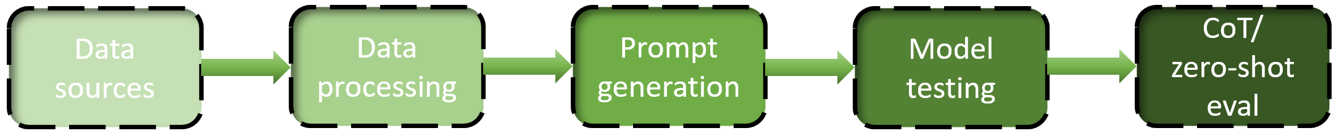
a)

b)
Figure 1. Diagnosis generation steps for few-shot Chain-of-Thought and zero-shot experiments (a) and for fine-tuned Llama 3.1 8B with zero-shot approach (b)
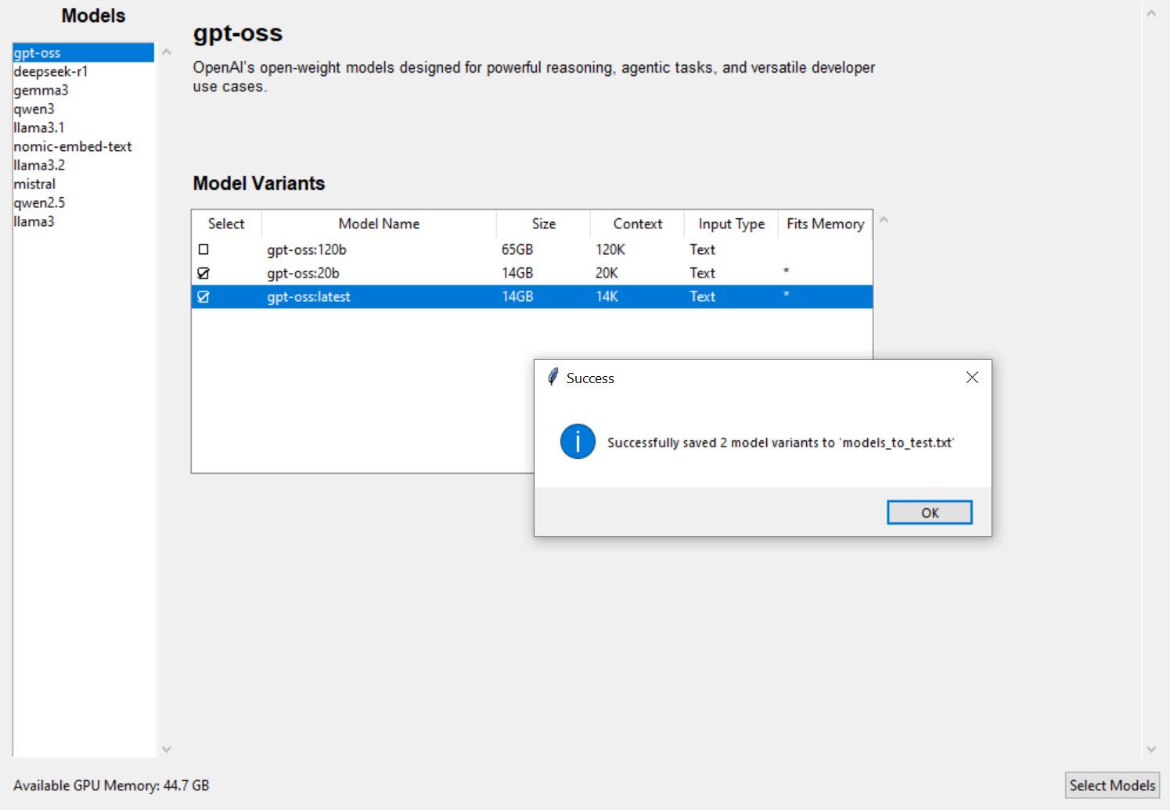
Figure 2. Selecting a family of models will reveal model name, size in GB, context length, the type of input it accepts, and if it will fit in the local VRAM of the GPU

4. LLM validation strategy on meteorological data

To assess the viability of LLMs for operational meteorological applications, we developed a validation approach testing both prompted reasoning and fine-tuned specialization on Romanian weather data. This framework evaluates whether language models can replicate the patterns meteorologists use when synthesizing observational data into coherent diagnoses (see Appendix A).

4.1. Processing pipelines

We considered two parts of the study: the first part includes a comprehensive LLM list receiving a test environment of Chain-of-Thought approach for the prompting strategy, and the second part consists of a fine-tuning environment for Llama3.1-8b-Instruct using the zero-shot prompting strategy.
First of all, the original data was preprocessed before creating the system or user prompts. We had 3 CSV files, each containing different types of weather data recorded from the ground stations across Romania. One of the files contained hourly data records with 7 columns capturing weather observations from Bucharest stations. The dataset includes station identifiers, location names, measurement timestamps, synoptic codes, wind speed measurements (in m/s), cloud coverage values (on 1-8 scale, where 1 = clear sky and 8 = cloud covered sky), and weather phenomena descriptions. Daily temperature table comprises records with 6 columns storing 24-hour temperature values (in °C). Each record contains maximum temperatures and minimum temperatures measured at specific weather stations across Bucharest (Filaret, Băneasa, Afumați), providing daily patterns essential for meteorological analysis of forecasts and diagnoses creation. Daily precipitation data contained with 5 columns documenting 24-hour rainfall measurements (l/m²). This dataset captures precipitation quantities across all Bucharest weather stations.
Professional meteorological reports from National Meteorological Administration of Romania (NMA) follow standardized formats. The PDF contains forecasts for the next 24 hours and the diagnoses for the past 24 hours. They present situation intervals for national conditions ("ÎN ȚARĂ") and Bucharest-specific analysis ("BUCUREȘTI"). These documents contain expert meteorological interpretations or automated notes, depending on the type of weather station the data was captured from, serving as ground truth for model training. We processed the CSV files by filtering data based on meteorological time periods. For hourly data, we extracted measurements within defined time windows from 8:30 AM of the previous day to 6:30 AM of the current day that align with meteorological observation periods from the PDF files. One of the scripts extracts all measurements from the three primary weather stations in Bucharest out of all operational weather stations found on the country’s territory, calculates a mean across stations for temperature and precipitation values, this way reducing noise from individual station anomalies or missing values. Another preprocessing step was done for weather phenomena stored as coded values. They were translated using predefined meteorological code tables. Numeric codes are converted into text, transforming entries such as coded precipitation types into readable descriptions such as "Ninsoare continuă - slabă în momentul observației." We also extract the text from meteorological reports by employing regex patterns to identify structural elements. The algorithm searches for specific Romanian markers such as "SITUAȚIA METEOROLOGICĂ PENTRU INTERVALUL" to locate time periods, then extracts the Bucharest section content between "BUCUREȘTI" headers and "PROGNOZĂ" boundaries. The processing pipeline synchronizes data from the described sources. Hourly measurements are aligned with daily temperature and precipitation records through average calculations or most encountered weather events in 24h timestamps, while being matched to the observation periods from the PDF files. This alignment ensures that training examples contain consistent temporal references.
The pipeline makes use of gpt-5-mini to generate step-by-step meteorological reasoning. For each day, gpt-5-mini receives both raw meteorological data and formatted diagnosis examples, then generates detailed reasoning chains that represent thought process, and thus the Chain-of-Thought approach (e.g. "Pentru fiecare propoziție din diagnoza meteorologică, gândește-te pas cu pas: 1. Ce informații specifice sunt necesare pentru această propoziție? 2. Ce date concrete din tabelele de mai jos susțin aceste informații?"). We create contexts by processing numbers of past days. Each day includes calculated temperature means from the three Bucharest stations, precipitation values, wind speed classifications, nebulosity values across days that transforms into a general pattern. Beside examples of reasoning traces in the user prompt for the past days system prompts include explicit step-by-step thinking instructions as well (e.g. "FOARTE IMPORTANT: Pentru fiecare propoziție din diagnoza ta, trebuie să explici mai întâi procesul de gândire pas cu pas, apoi să formulezi raspunsul respectand structura definite anterior." This instruction forces models to engage in the reasoning process more often.
Usually, the text of a diagnose contains around 5 statements about general weather observations, comparison with the previous day, if the persistence of a phenomena affects the weather, the maximum and minimum temperatures for each weather station from Bucharest, and the registered temperatures at the same stations at 6 AM. Text similarity metrics are then calculated. ROUGE-L scores assess n-gram overlap between generated response and reference diagnoses. BLEU, METEOR, and BERT scores are calculated for semantic similarity analysis. BERT Score evaluation uses multilingual BERT and embeddings for Romanian text. We employed gpt-5-mini as a semantic evaluator, scoring correlation between generated and reference diagnoses. The judge model receives detailed evaluation criteria and generates correlation scores between each sentence. Then we apply regex pattern matching to extract numerical correlation arrays from judge responses. It handles both four and five-sentence analyses, validates score ranges in the interval [0, 1], and calculates average correlations for gathering insights.
In the case of zero-shot fine-tuning pipeline, the first module implements the creation of training dataset that converts raw meteorological data into instruction-following format. Each training example follows the messages format fine-tuning: system prompt having an instruction-based structure, user prompt containing an average over the weather data for the past 24 hours, and assistant response with ground-truth diagnosis. Test prompts are created without Chain-of-Thought examples from the OpenAI API reasoning chains. The weather data is extracted using the same algorithm as for the training dataset, generating minimal user prompts containing only meteorological measurements. This approach tests model capabilities learned during fine-tuning rather than in-context learning from a reasoning chain. To eliminate response verbosity, instructions such as "NU repeta informațiile din prompt" and "CONCENTREAZĂ-TE EXCLUSIV pe ziua pentru care se cere diagnoza" were added in the system prompt.
The Llama3.1-8B model was set to perform parameter-efficient fine-tuning using LoRA adapters with rank 32, only the weights of attention and feed-forward layers remained trainable, all the other layers stayed frozen. A 4-bit quantization was used during the training process. For assimilating the Romanian meteorological vocabulary, 3 epochs with 2e-4 learning rate and gradient accumulation configuration represented the setup parameters. After training, Llama generates responses using a temperature = 0.7 and top-p = 0.9. The system uses fixed testing dates (30th of January, March, May, July, September, November) defined in the configuration file and training dates are defined by the first 25 days of each month.

4.2. Data insights and results

For both testing phases, few-shot CoT (Wei et al. 2022) and LLM-as-a-Judge (Pezeshkpour et al. 2024), we will look at 10th and 25th of July, as the 7th month of the calendar is usually the most eventful month of the year when it comes to severe weather events, such as heavy rain or lightning storms.
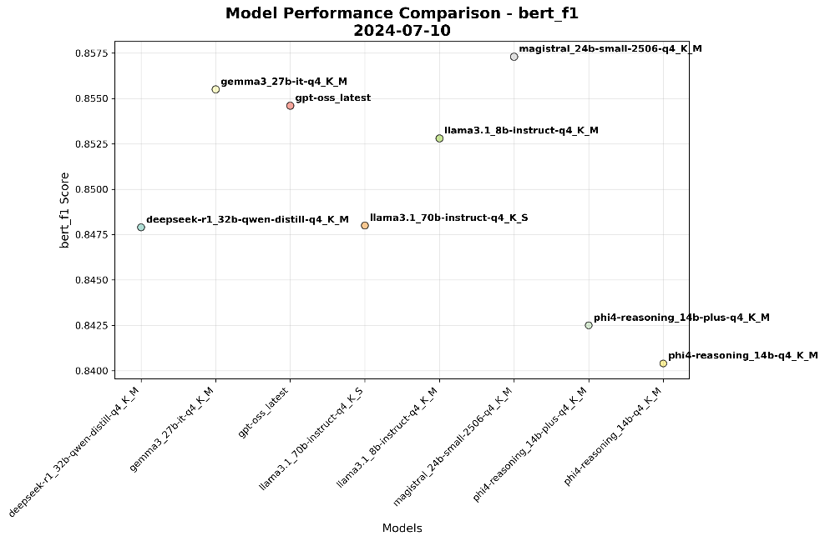
Figure 3. BERT score for 10th of July across all tested models and past days

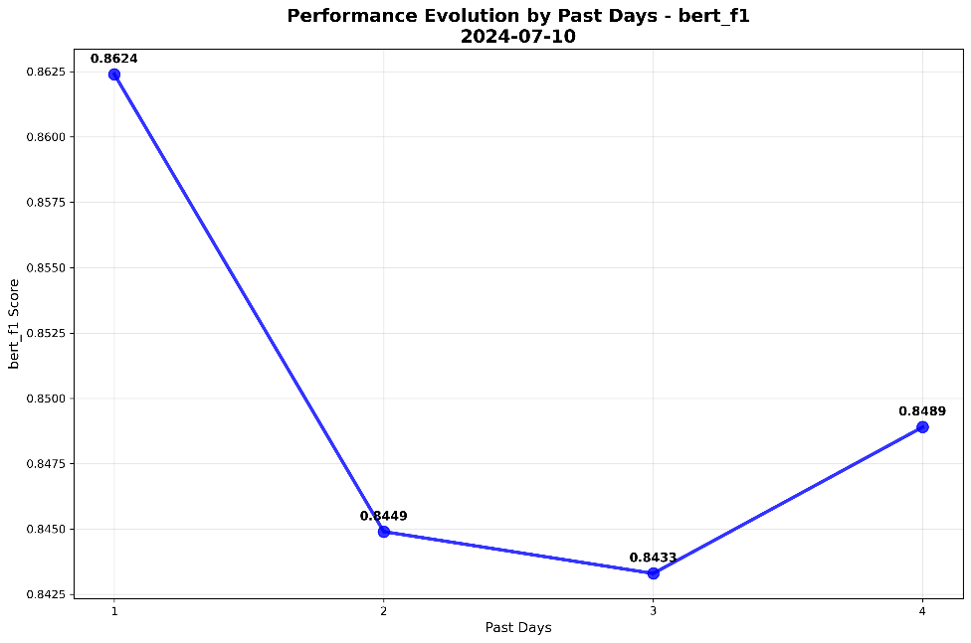

Figure 4. BERT score for 10th of July averaged per day
Looking at the data we can see that Magistral 24B achieves the highest BERT Score at 0.8575, followed by Gemma3 27B at ~0.855. The performance of GPT-OSS-20B (latest open-source model introduced by OpenAI in the Ollama repo) at ~0.85 suggests that recent architectural improvements can compensate for smaller model sizes. Phi4-Reasoning models scored the lowest out of all models despite the fact that the reasoning feature is incorporated by default. This points out that reasoning capabilities do not always perform better when considering domain-specific knowledge compared to larger, GPT-like models. The past days evolution chart reveals peak performance at 1 past day. This may indicate that meteorological diagnosis generation benefits from minimal historical context, contradicting our assumption that more historical data improves forecasting accuracy. The performance drop from 1 to 2 past days, which we calculated to be around 1.75% decrease indicates that Chain-of-Thought prompting suffers from information overload as processing more historical weather patterns can make the model more susceptible to hallucinations.
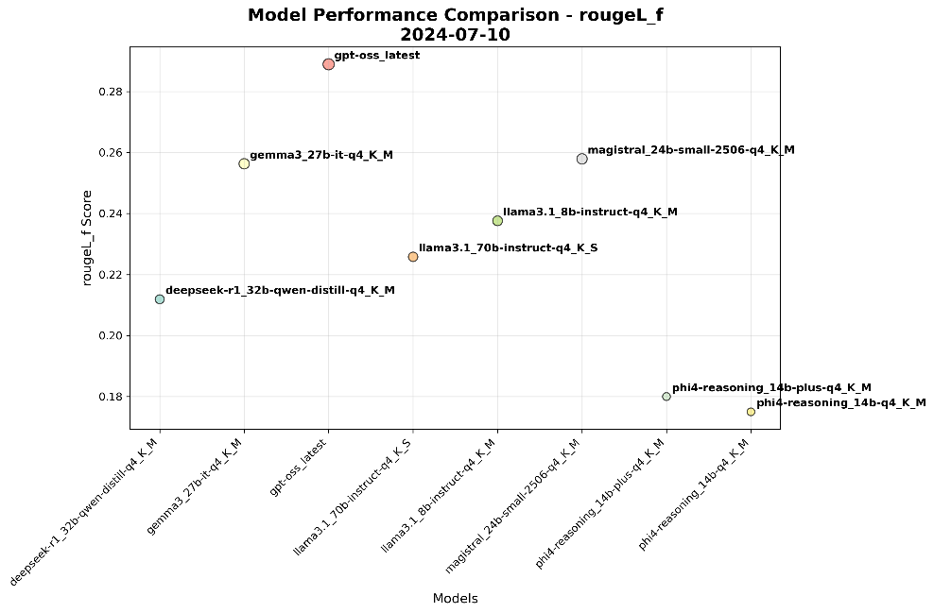
Figure 5. ROUGE-L score for 10th of July across all tested models and past days
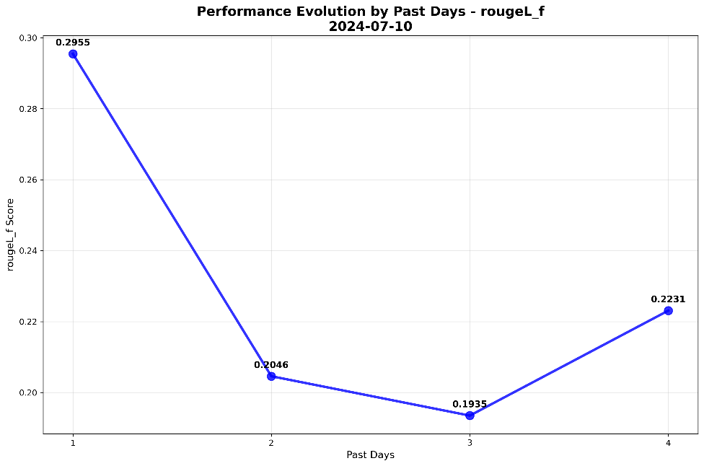

Figure 6. ROUGE-L score for 10th of July averaged per day

GPT-OSS is the leading model at ~0.29 ROUGE-L, outperforming the previous BERT Score leaders. This indicates that GPT-OSS is better at lexical matching with reference meteorological texts. The lower ROUGE-L scores compared to BERT Score reveals that models struggle more with exact word matching than semantic similarity. This suggests that models rarely reproduce the lexical formulations used in reference texts. Phi4-Reasoning models persist as the lowest scoring models, lacking domain-specific vocabulary. The poor performance across both semantic and lexical metrics may indicates limitations in meteorological domain adaptation compared to other models.

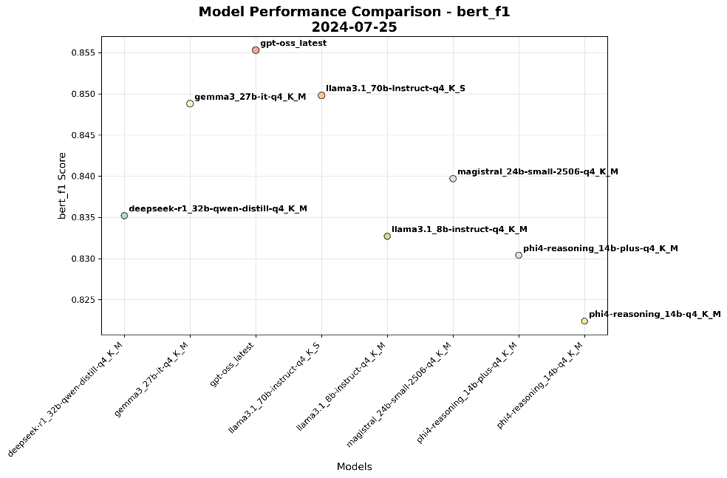
Figure 7. BERT score for 25th of July across all tested models and past days

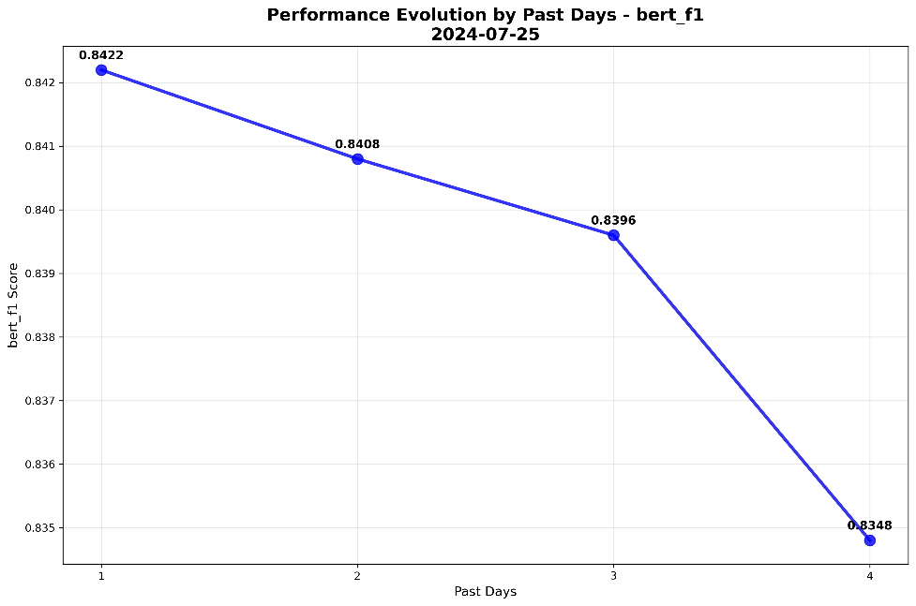
Figure 8. BERT score for 25th of July averaged per day
For the 25th of July, the temporal evolution shows a monotonic decline that is in contrast with the July 10th U shape plot. We believe that the contrast between July 10th and 25th results mean that Chain-of-Thought performance is highly dependent by the weather conditions that are analyzed. The more diverse weather events, the higher chances that models will hallucinate sooner, given a sufficient short time window. July 10th showed optimal performance with minimal context of just 1 past day present in the user prompt and a recovery trend at 4 past days, while July 25th still peaks at 1 past day, but continues to degrade over longer historical contexts, although at a slower rate. The same observations apply for ROUGE-L score, but having even a lower value than before.

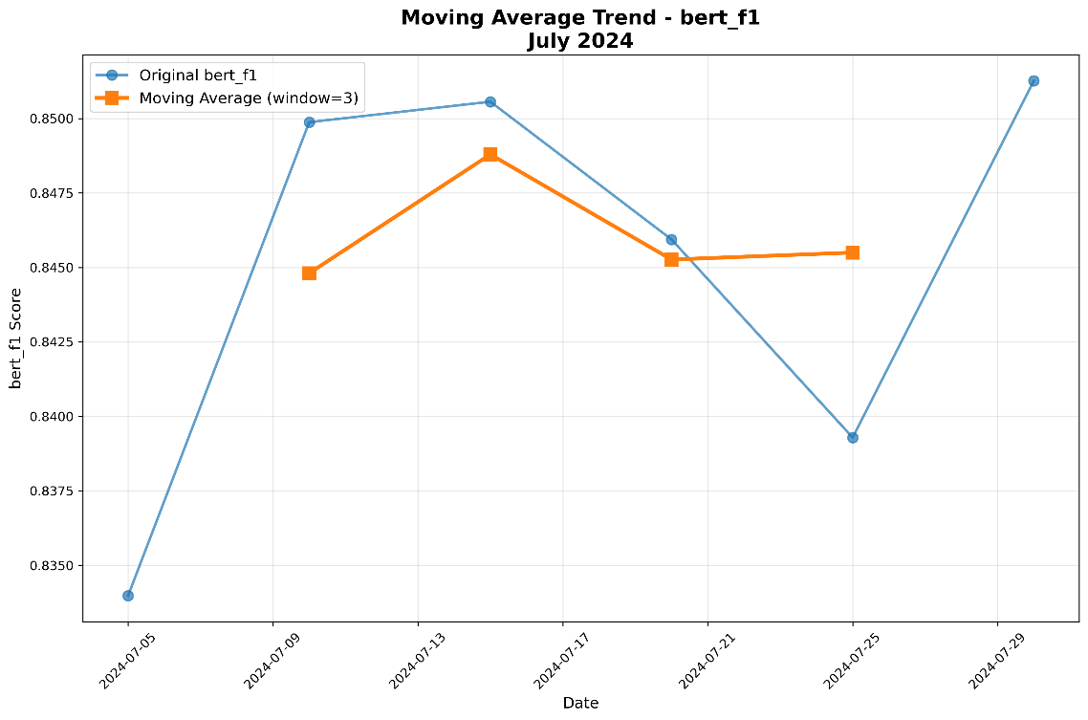
Figure 9. BERT moving average across all test scenarios
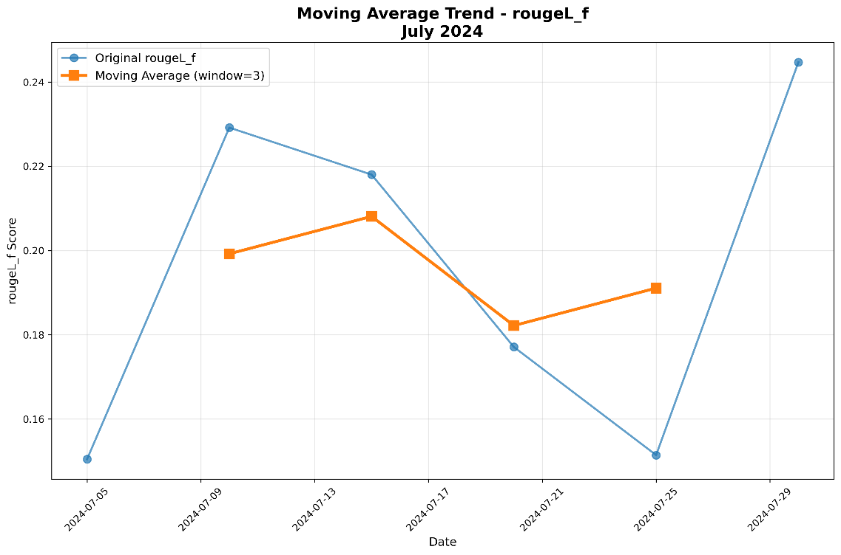
Figure 10. ROUGE-L moving average across all test scenarios
One key note regarding the moving average is that LLMs rely on well-structured data as well as consistent information gain through the user prompt. This shows that model capabilities remain stable when temporal noise is filtered out or avoided, when possible.
When it comes to the overall comparison between the 2 analyzed days can be summed up through the rest of the metrics. For the 10th of July from the ROUGE score we notice that the majority of the generated diagnoses has higher lexical similarity with the reference diagnoses, compared to 25th of July. This can be translated as the weather patterns of test samples were more recognizable and easier to understand by the LMs. BLEU scores show that, when comparing the 2 days, the one that appears first in a chronological order achieved much better n-gram precision. METEOR scores follow a similar pattern. METEOR accounts for stemming and thus semantic similarity is maintained for certain portions of the text. From the Jaccard similarity we can confirm that the lexical overlap shows less word-level intersection for the second test set.
 | Rouge-L | BLEU | BERT | METEOR | Jaccard similarity
count | 32 | 32 | 32 | 32 | 32
mean | 0.2292 | 0.0516 | 0.8499 | 0.2289 | 0.1383
std | 0.0718 | 0.05 | 0.0127 | 0.0623 | 0.0444
min | 0.1252 | 0.0069 | 0.8323 | 0.1389 | 0.0709
25% | 0.176 | 0.0174 | 0.8409 | 0.1892 | 0.1063
50% | 0.2057 | 0.0397 | 0.8462 | 0.2202 | 0.126
75% | 0.2758 | 0.0612 | 0.8565 | 0.2652 | 0.166
max | 0.4103 | 0.2074 | 0.8842 | 0.3921 | 0.2375

Table 1. Metrics for 10th of July

 | Rouge-L | BLEU | BERT | METEOR | Jaccard similarity
count | 32 | 32 | 32 | 32 | 32
mean | 0.1526 | 0.0196 | 0.8395 | 0.1716 | 0.0882
std | 0.0502 | 0.0163 | 0.0154 | 0.0547 | 0.031
min | 0.0399 | 0.0012 | 0.7845 | 0.0237 | 0.0045
25% | 0.1282 | 0.0072 | 0.8335 | 0.1467 | 0.0714
50% | 0.1441 | 0.0131 | 0.8405 | 0.174 | 0.0918
75% | 0.1677 | 0.0336 | 0.8452 | 0.1966 | 0.104
max | 0.2764 | 0.0512 | 0.8667 | 0.2699 | 0.1484

Table 2. Metrics for 25th of July
For the LLM scoring of prompts case, the evaluation pipeline uses LLM-as-a-Judge (Gu et al., 2024) framework. The judge is an experienced meteorologist from National Meteorological Administration of Romania. The model, that being gpt-5-mini, is instructed to use a standardized five-sentence structure to compare model responses to reference diagnoses. Each sentence gets a correlation score between 0 and 1. If the temperature difference is more than 2 °C or the wind speed difference is more than 5 m/s, there will be significant penalties applied to the score given. The evaluation structure is similar to what is required for professional meteorological reporting. It includes general weather observations compared to previous days, sky nebulosity and wind conditions using standardized scales, optional repeated weather phenomena, maximum temperatures at the three Bucharest stations, and morning temperature predictions.
The system starts by loading structured diagnoses from prior years, in this case it was for 2024. Then, it creates step-by-step GPT replies for past days to use as contextual examples. These answers give models real instances of how to use Romanian technical terms and meteorological reasoning. The full meteorological data extraction arranges information by day, such as average temperatures, patterns of precipitation, wind statistics, measurements of nebulosity, and occurrences of weather events. To implement the CoT reasoning efficiently the model has to explain how it came to each diagnostic statement from the set of five.
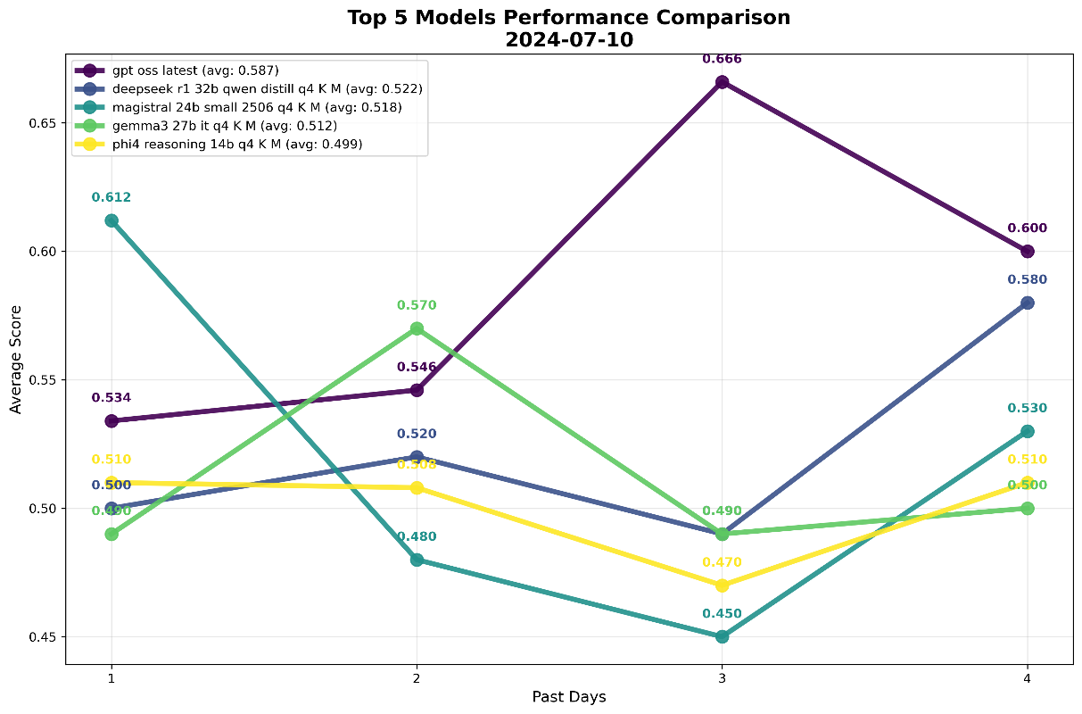
Figure 11. Top 5 model scores averaged over past days context on 10th of July
The performance study shows a huge difference that makes us question what we thought we knew about how well models work in specific areas. On July 10th, scores ranged from 0.45 to 0.67. On July 25th, they dropped to a range of 0.03 to 0.35, which is a significant drop in performance across all models. This difference could mean that the weather conditions make the diagnostics more complicated, or that the models are sensitive to certain weather patterns or language structures in Romanian meteorological terminology.
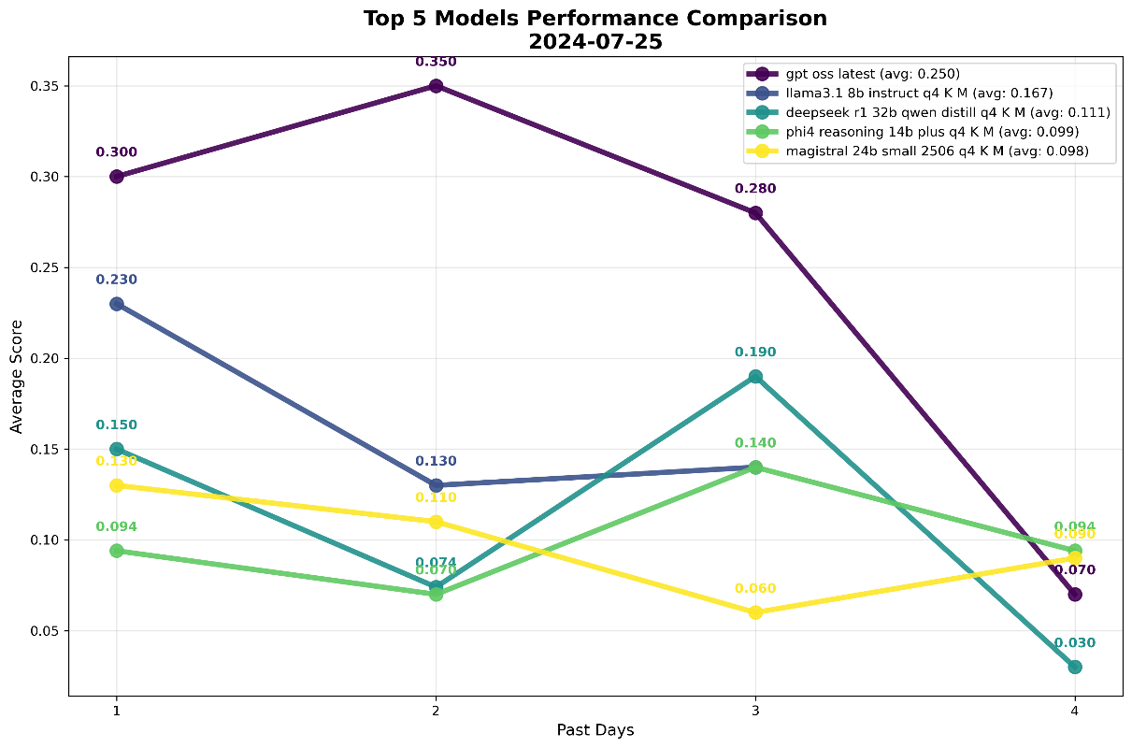
Figure 12. Top 5 model scores averaged over past days context on 25th of July
The impacts of context length on language models go against what most people think about how useful information is. Most models don't keep getting better with more historical data; instead, they peak at 2–3 days in the past, after which performance either levels out or gets worse. This trend indicates that meteorological diagnostic tasks possess optimal context windows, wherein supplementary information transforms into unwanted noise. The non-linear relationship between context length and performance suggests that models may experience information saturation when handling large meteorological sequences, similar to how human experts become confused when confronted with excessive data lacking clear relevance to current conditions. The latest open-source model from OpenAI, GPT-OSS 20B, does better than other architectures when it comes to both dates and past context. This evaluation strategy employs methodological difficulties that require careful attention. The correlation-based scoring system may not account for changes in meteorological instruments that are significant in many contexts. Furthermore, the task may surpass the capacity of the existing model for accurate meteorological diagnosis, also considering the necessity for precise numerical precision and specialized Romanian terminology that the models may not have been trained on.
 | 30th day | 25th day | 20th day | 15th day | 10th day |  | 5th day
count | 32 | 32 | 32 | 32 |  | 32 | 32
mean | 0.16625 | 0.12271 | 0.322563 | 0.504 |  | 0.484437 | 0.215
std | 0.07277 | 0.077081 | 0.122633 | 0.136174 |  | 0.099018 | 0.089515
min | 0.03 | 0.03 | 0.15 | 0.21 |  | 0.2 | 0.07
25% | 0.09 | 0.07 | 0.2175 | 0.4225 |  | 0.465 | 0.1475
50% | 0.168 | 0.1 | 0.317 | 0.514 |  | 0.5 | 0.215
75% | 0.2315 | 0.145 | 0.3825 | 0.624 |  | 0.531 | 0.2625
max | 0.28 | 0.35 | 0.576 | 0.696 |  | 0.666 | 0.45
Table 3. Judge (gpt-5-mini) scores across all models for each tested day of July

The evaluation between the LLM-as-a-Judge scores and the traditional NLP metrics from moving average plots show recovery toward July 30th. However, the judge scores for July 30th remains modest at 0.16625, suggesting that while models demonstrate lexical and semantic coherence, they still struggled with meteorological accuracy and structured reasoning that the expert evaluator prioritized. This difference reveals the limitation of statistical metrics in capturing domain-specific expertise requirements for LLM evaluation.
The judge evaluation shows peak performance on July 15th with 0.504 and July 10th with 0.484, while the moving average metrics peak primarily around July 10th. The judge weighted factors such as temperature and wind speed differences, more than semantic similarity algorithms. The consistent identification of July 25th as the global minimum across all evaluation scenarios validates the hypothesis that meteorological variety impacts model reliability.

date | Rouge-L |  | BLEU | BERT | METEOR | Jaccard similarity
2024-01-30 | 0.3678 | 0.1157 |  | 0.8914 | 0.2566 | 0.2442
2024-03-30 | 0.36 | 0.0816 |  | 0.8893 | 0.3055 | 0.2424
2024-05-30 | 0.329 | 0.0234 |  | 0.8738 | 0.2188 | 0.1892
2024-07-30 | 0.41 | 0.2289 |  | 0.8865 | 0.4068 | 0.2417
2024-09-30 | 0.3216 | 0.0791 |  | 0.8778 | 0.2374 | 0.1983
2024-11-30 | 0.3927 | 0.1629 |  | 0.8998 | 0.3712 | 0.2947

Table 4. Zero-shot test results on statistical evaluation metrics of Llama3.1-8B-Instruct. Bolded are the best values of each metric
The fine-tuned Llama3.1-8B-Instruct demonstrates performance improvements over the CoT strategy for July 30th. For ROUGE-L, the zero-shot fine-tuned model achieves 0.41 compared to the CoT average of ~0.25, representing 82% improvement in lexical overlap. The BERT Score improvement is modest, with the fine-tuned model scoring 0.8865 compared to the CoT average of ~0.85, representing a 4% gain in semantic similarity.
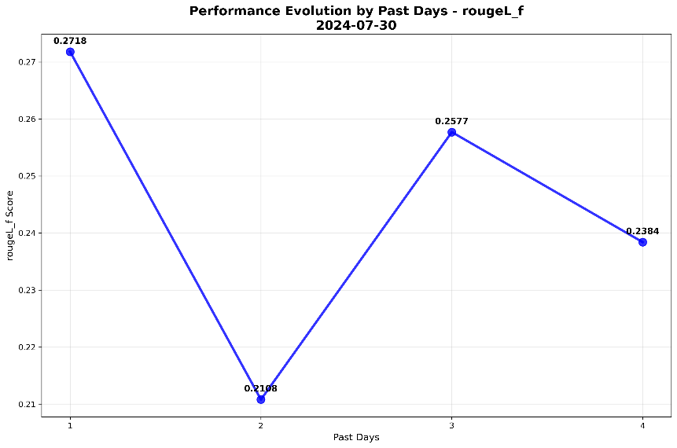

Figure 13. ROUGE-L score for 30th of July averaged per day
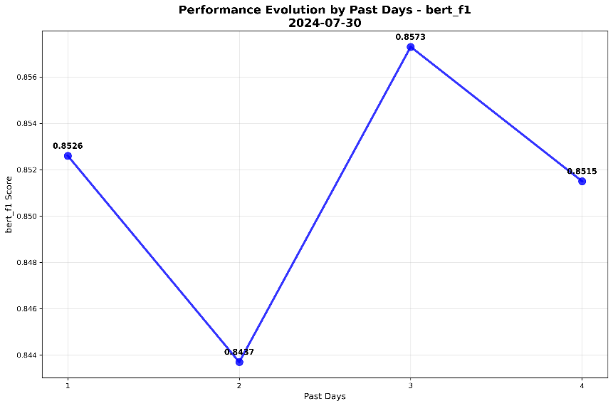

Figure 14. BERT score for 30th of July averaged per day

5. Conclusions and next steps

This study highlights the capabilities and constraints of LLMs in certain meteorological reasoning tasks. The experimental results show that creating meteorological diagnoses is a difficult task that depends on the weather events. The difference in performance between July 10th and July 25th, when scores dropped from 0.45–0.67 to 0.03–0.35 for all evaluated models, shows that existing LLMs have trouble being consistent in specialized technical fields. This unpredictability indicates that atmospheric complexity directly affects model reliability.
Another key finding is that most models did not improve over time with more data provided. Instead, they worked best with shorter contexts of 1 or 2 past days. This study has practical implications for meteorological applications, indicating that selected context windows may be more useful for certain applications than extensive temporal data integration. The non-linear link between context length and performance suggests that domain-specific applications necessitate customized prompting tactics distinct from general-purpose usage patterns.
Using LLM-as-a-Judge with gpt-5-mini to evaluate gives useful information about how to arrange the assessment of technical evaluations, but it also shows how hard it is to keep the same standards across different weather circumstances. The correlation-based scoring approach addressed domain-specific requirements, including temperature accuracy thresholds and wind speed precision. However, the substantial score fluctuations between test dates cast doubt on the durability of evaluations in specialized domains.
The open-source model from OpenAI, that being GPT-OSS-20B, demonstrated better structured text generation capabilities, even when compared to models that can reason, like phi4-reasoning-14b. The difference between semantic similarity (BERT Score) and lexical overlap (ROUGE-L) scores shows that existing algorithms can understand concepts but have trouble reproducing exact meteorological terms. The fine-tuning tests using Llama3.1-8B show that parameter-efficient methods can change general-purpose models to work in the meteorological field, even with only 300 training samples, guided only by the system prompt to respect a general structure of the response, with validating and generating accurate numerical values being the main challenge of LLM training.
Future research must focus on numerous essential domains to enhance LLM capabilities in other applications. First, creating evaluation frameworks that take into consideration the natural changes in weather while keeping the same standards for all types of weather. This includes developing benchmarks for meteorological reasoning. Creating specialized meteorological training datasets is another important step that can be done. Current models benefit from fine-tuning that is specific to a certain domain. Future research should investigate multi-modal training that integrates satellite images, radar data, and numerical weather model outputs with textual meteorological reports to enhance the domain knowledge about atmospheric conditions.
We need to do more research on context optimization techniques to find the best way to provide information for different weather scenarios, to achieve better analytical results on the long term. Future study should investigate the integration of LLM-generated diagnoses with numerical weather prediction models. Moreover, human-in-the-loop should be promoted in supervising automated systems to reduce uncertainty and hallucination events that current LLM implementations suffer from.
An interesting research topic could be cross-lingual transfer learning methods that utilize meteorological expertise from languages such as English, or languages where current iterations of LLMs have been extensively trained on while preserving precision in local terminology and communication norms.
Lastly, we need to think about how using LLMs in operational meteorology would affect the environment. Future research should investigate model compression methods, effective inference techniques, especially considering that nowcasting systems have evolved and are being utilized on a daily basis in the prediction of severe weather events for up to 24 hours. The goal should be to create technologies that improve, not replace, human meteorological knowledge and can be used in the field in a way that is both cost-effective and long-lasting.

References

Wei, J., Wang, X., Schuurmans, D., Bosma, M., Ichter, B., Xia, F., Chi, E., Le, Q., & Zhou, D. (2023). Chain-of-Thought Prompting Elicits Reasoning in Large Language Models. http://arxiv.org/abs/2201.11903
Chen, M., Tworek, J., Jun, H., Yuan, Q., Pinto, H. P. de O., Kaplan, J., Edwards, H., Burda, Y., Joseph, N., Brockman, G., Ray, A., Puri, R., Krueger, G., Petrov, M., Khlaaf, H., Sastry, G., Mishkin, P., Chan, B., Gray, S., … Zaremba, W. (2021). Evaluating Large Language Models Trained on Code. http://arxiv.org/abs/2107.03374
Chang, Y., Wang, X. U., Wu, Y., Chen, H., Yi, X., Ye, W., Zhang, Y., Chang, Y. I., Yu, P. S., Chang, Y., Wang, X., Wang, J., Yang, L., Zhu, K., Wang, C., Wang, Y., Yang, Q., & Xie, X. (2018). A Survey on Evaluation of Large Language Models. In Journal of the ACM (Vol. 37, Issue 4).
Villalobos, P., Ho, A., Sevilla, J., Besiroglu, T., Heim, L., & Hobbhahn, M. (2024). Will we run out of data? Limits of LLM scaling based on human-generated data. http://arxiv.org/abs/2211.04325
Lang, S., Alexe, M., Chantry, M., Dramsch, J., Pinault, F., Raoult, B., Clare, M. C. A., Lessig, C., Maier-Gerber, M., Magnusson, L., Bouallègue, Z. ben, Nemesio, A. P., Dueben, P. D., Brown, A., Pappenberger, F., & Rabier, F. (2024). AIFS -- ECMWF’s data-driven forecasting system. http://arxiv.org/abs/2406.01465
Lam, R., Sanchez-Gonzalez, A., Willson, M., Wirnsberger, P., Fortunato, M., Alet, F., Ravuri, S., Ewalds, T., Eaton-Rosen, Z., Hu, W., Merose, A., Hoyer, S., Holland, G., Vinyals, O., Stott, J., Pritzel, A., Mohamed, S., & Battaglia, P. (2023). GraphCast: Learning skillful medium-range global weather forecasting. http://arxiv.org/abs/2212.12794
Bi, K., Xie, L., Zhang, H., Chen, X., Gu, X., & Tian, Q. (2023). Accurate medium-range global weather forecasting with 3D neural networks. Nature, 619(7970), 533–538. https://doi.org/10.1038/s41586-023-06185-3
Andrychowicz, M., Espeholt, L., Li, D., Merchant, S., Merose, A., Zyda, F., Agrawal, S., & Kalchbrenner, N. (2023). Deep Learning for Day Forecasts from Sparse Observations. http://arxiv.org/abs/2306.06079
Wang, Yong & Coning, Estelle & Harou, Abdoulaye & Jacobs, Wilfried & Joe, Paul & Nikitina, Larisa & Roberts, Rita & Wang, Jianjie & Wilson, Jim & Atencia, Aitor & Bica, Benedikt & Brown, Barbara & Goodmann, Steven & Kann, Alexander & Li, Ping Wah & Monterio, Isabel & Schmid, Franziska & Seed, Alan & Sun, Jenny. (2017). Guidelines for Nowcasting Techniques.
Ancuța Manea, Viorica Dima, Alexandru Dumitrescu, Paula Maco, Gina Tiron, Adelina Potra, Ioana Goia, George-Stelian Tudorache, Andrei Ionel Bergheș, Cristian Oprea, Adrian Rădulescu, Elena Toma, & Elena Mateescu. (2017). VOLUMUL I Efectuarea măsurătorilor și observațiilor meteorologice, codificarea datelor meteorologice.
Zängl, G., Reinert, D., Rípodas, P. and Baldauf, M. (2015), The ICON (ICOsahedral Non-hydrostatic) modelling framework of DWD and MPI-M: Description of the non-hydrostatic dynamical core. Q.J.R. Meteorol. Soc., 141: 563-579. https://doi.org/10.1002/qj.2378
Thakur, A. S., Choudhary, K., Ramayapally, V. S., Vaidyanathan, S., & Hupkes, D. (2025). Judging the Judges: Evaluating Alignment and Vulnerabilities in LLMs-as-Judges. http://arxiv.org/abs/2406.12624
Gu, J., Jiang, X., Shi, Z., Tan, H., Zhai, X., Xu, C., Li, W., Shen, Y., Ma, S., Liu, H., Wang, S., Zhang, K., Wang, Y., Gao, W., Ni, L., & Guo, J. (2025). A Survey on LLM-as-a-Judge. http://arxiv.org/abs/2411.15594
Kevian, D., Syed, U., Guo, X., Havens, A., Dullerud, G., Seiler, P., Qin, L., & Hu, B. (2024). Capabilities of Large Language Models in Control Engineering: A Benchmark Study on GPT-4, Claude 3 Opus, and Gemini 1.0 Ultra. http://arxiv.org/abs/2404.03647
Kevian, D., Syed, U., Guo, X., Havens, A., Dullerud, G., Seiler, P., Qin, L., & Hu, B. (2024). Capabilities of Large Language Models in Control Engineering: A Benchmark Study on GPT-4, Claude 3 Opus, and Gemini 1.0 Ultra. http://arxiv.org/abs/2404.03647
Jiang, Q., Gao, Z., & Karniadakis, G. E. (2025). DeepSeek vs. ChatGPT vs. Claude: A Comparative Study for Scientific Computing and Scientific Machine Learning Tasks. http://arxiv.org/abs/2502.17764
Liu, F., Li, Z., Zhou, H., Yin, Q., Yang, J., Tang, X., Luo, C., Zeng, M., Jiang, H., Gao, Y., Nigam, P., Nag, S., Yin, B., Hua, Y., Zhou, X., Rohanian, O., Thakur, A., Clifton, L., & Clifton, D. A. (2024). Large Language Models in the Clinic: A Comprehensive Benchmark. http://arxiv.org/abs/2405.00716
Ziems, C., Held, W., Shaikh, O., Chen, J., Zhang, Z., & Yang, D. (2024). Can Large Language Models Transform Computational Social Science? http://arxiv.org/abs/2305.03514
Huang, Y., Yuan, Z., Zhou, Y., Guo, K., Wang, X., Zhuang, H., Sun, W., Sun, L., Wang, J., Ye, Y., & Zhang, X. (2024). Social Science Meets LLMs: How Reliable Are Large Language Models in Social Simulations? http://arxiv.org/abs/2410.23426
Hendrycks, D., Burns, C., Basart, S., Zou, A., Mazeika, M., Song, D., & Steinhardt, J. (2021). Measuring Massive Multitask Language Understanding. http://arxiv.org/abs/2009.03300
Hendrycks, D., Burns, C., Kadavath, S., Arora, A., Basart, S., Tang, E., Song, D., & Steinhardt, J. (2021). Measuring Mathematical Problem Solving With the MATH Dataset. http://arxiv.org/abs/2103.03874
Zellers, R., Holtzman, A., Bisk, Y., Farhadi, A., & Choi, Y. (2019). HellaSwag: Can a Machine Really Finish Your Sentence? http://arxiv.org/abs/1905.07830
Hu, E. J., Shen, Y., Wallis, P., Allen-Zhu, Z., Li, Y., Wang, S., Wang, L., & Chen, W. (2021). LoRA: Low-Rank Adaptation of Large Language Models. http://arxiv.org/abs/2106.09685
Ding, N., Qin, Y., Yang, G., Wei, F., Yang, Z., Su, Y., Hu, S., Chen, Y., Chan, C. M., Chen, W., Yi, J., Zhao, W., Wang, X., Liu, Z., Zheng, H. T., Chen, J., Liu, Y., Tang, J., Li, J., & Sun, M. (2023). Parameter-efficient fine-tuning of large-scale pre-trained language models. Nature Machine Intelligence, 5(3), 220–235. https://doi.org/10.1038/s42256-023-00626-4
Ollama. Ollama. Accessed September 7, 2025. https://ollama.com/search

Appendix A: Examples of prompts and responses
For the user prompt of the few-shot CoT approach we constructed prompts with a standard defined structure and providing information about the weather of the previous 4 days can be seen in the example below.
ATENȚIE: Creează diagnoza meteorologică DOAR pentru ziua 2024-07-30. NU repeta informațiile din prompt.

Analiza meteorologică pentru diagnoză:

INSTRUCȚIUNI PENTRU GÂNDIRE PAS CU PAS:
Pentru fiecare propoziție din diagnoza meteorologică, gândește-te pas cu pas:
1. Ce informații specifice sunt necesare pentru această propoziție?
2. Ce date concrete din tabelele de mai jos susțin aceste informații?
3. Cum se compară aceste date cu zilele precedente?
4. Care este concluzia logică pe baza acestor comparații?
5. Cum formulezi această concluzie într-un mod profesional, specific ANM?

EXEMPLE DE ANALIZE METEOROLOGICE ANTERIOARE:

ZIUA 2024-07-29:
Temperatura medie maximă București: 33.4°C
Temperatura medie minimă București: 19.2°C
Precipitații medii București: 0.0 l/m²
Vânt: Media 5.7 m/s (min: 1.1, max: 11.2)
Nebulozitate: Cel mai frecvent 0/8 (29 măsurători)
Fenomene:
- Nu sunt fenomene semnificative: 69 observații
Diagnoza pentru 2024-07-29:
Diagnoza GPT-5-mini:
"Explicație pas cu pas:
- Compar înregistrările curente cu tendința zilelor precedente (date nu oferite direct pentru zile anterioare, dar avem temperatura medie maximă și minimă pentru ziua curentă).
- Observ că temperatura medie maximă este 33.4°C, ceea ce indică valori ridicate, tipic pentru o zi caniculară de vară.
- Nu există precipitații medii (0.0 l/m²), deci ziua a fost uscată.
- Concluzionez că, în ansamblu, temperatura a fost peste valorile normale de referință pentru o zi obișnuită de vară, rezultând condiții calde spre caniculare.

Prin urmare, PRIMA PROPOZIȚIE: Valorile termice au fost ridicate, cu o temperatură maximă medie de 33,4°C și o minimă medie de 19,2°C, indicând o zi caldă spre caniculară în comparație cu condițiile climatologice obișnuite, iar evenimentele meteorologice au fost caracterizate de vreme uscată (precipitații medii 0,0 l/m²).

Explicație pas cu pas:
- Analizez starea cerului pe baza nebulozității: cel mai frecvent 0/8 la 29 de măsurători înseamnă predominant cer senin.
- Evaluez vântul: media 5,7 m/s; conform pragurilor indicate, sub 3 m/s = slab, peste 6 m/s = puternic. Media 5,7 m/s este între 3 și 6 m/s, deci vântul a fost moderat; dar trebuie respectat criteriul: sub 3 slab, peste 6 puternic — aș spune „slab până la moderat” sau „moderate”.
- Având min 1,1 și max 11,2 m/s, au existat rafale ce au atins 11,2 m/s — acestea indică episoade de vânt mai puternic, dar nu permanente.

Prin urmare, A DOUA PROPOZIȚIE: Cerul a fost predominant senin (nebulozitate frecventă 0/8), iar vântul a suflat în general moderat (media 5,7 m/s), cu rafale izolate care au atins până la 11,2 m/s.

Explicație pas cu pas:
- Verific dacă există fenomene meteorologice repetate în ultimele 24 h: datele arată „Nu sunt fenomene semnificative: 69 observații” și precipitații 0.0 — deci nu s-au repetat fenomene precum ploi, ceață sau ninsoare.
- Concluzionez că propoziția opțională despre fenomene repetate nu se aplică.

(Notă: Deoarece nu au fost fenomene repetate, omitem propoziția opțională.)

Explicație pas cu pas:
- Trebuie să furnizez temperatura maximă înregistrată la cele 3 stații din București: Filaret, Băneasa și Afumați.
- Datele primite nu prezintă valorile maxime separate pe stații; am însă temperatura medie maximă pentru București 33,4°C.
- În lipsa valorilor individuale, cel mai corect din perspectiva profesională este să raportez temperatura maximă medie pentru rețea și să precizez că nu dispun de valori distincte pe stații.
- Formulez propoziția astfel încât să fiu precis și transparent privind absența datelor diferențiate.

Prin urmare, A PATRA PROPOZIȚIE: Temperatura maximă medie înregistrată pentru București a fost 33,4°C; valorile maxime specifice stațiilor Filaret, Băneasa și Afumați nu sunt disponibile în setul de date furnizat.

Explicație pas cu pas:
- Trebuie să prezic temperaturile la ora 06:00 pentru cele trei stații, folosind informațiile disponibile: minimă medie 19,2°C pentru București și condiții de seninitate care favorizează răcirea nocturnă, dar cu minimă medie relativ ridicată.
- În general, pentru o minimă medie urbană de 19,2°C, variațiile între stații pot fi de câteva grade: Băneasa (zona periurbană, mai răcoros), Filaret (centru-sud, mai cald urban), Afumați (est, periurban, ușor mai rece).
- Având în vedere condițiile senine și vânt moderat (care limitează răcirea foarte accentuată), estimez valori la ora 06:00 apropiate de minimă medie, cu diferențe locale de 1–3°C: Filaret puțin mai cald (+2°C față de medie), Băneasa mai rece (-2°C față de medie), Afumați aproape de medie (-1°C).
- Calcul: medie minimă 19,2°C → Filaret ≈ 21°C, Băneasa ≈ 17°C, Afumați ≈ 18°C.

Prin urmare, PROPOZIȚIA FINALĂ: La ora 06:00 estimăm temperaturi de aproximativ 21,0°C la Filaret, 17,0°C la Băneasa și 18,0°C la Afumați."

…

DATELE METEOROLOGICE PENTRU DIAGNOZA CURENTĂ (2024-07-30):

ANALIZA VÂNTULUI (Rff1):
- Viteza medie înregistrată: 4.2 m/s
- Numărul total de măsurători: 285
- Caracterizare: vânt moderat

ANALIZA NEBULOZITĂȚII (Nop):
- Valoarea cea mai frecventă: 0/8 (pe scala 1-8)
- Numărul de înregistrări cu această valoare: 151
- Caracterizare: cer senin sau puțin noros
- Cele mai frecvente ore de apariție: 23:00, 00:00, 08:00

ANALIZA PRECIPITAȚIILOR:
- 26.07.2024: 11.8 l/m² (zi cu precipitații)
- 27.07.2024: 0.0 l/m² (zi fără precipitații)
- 28.07.2024: 0.0 l/m² (zi fără precipitații)
- 29.07.2024: 0.0 l/m² (zi fără precipitații)

Bilanțul precipitațiilor în perioada analizată:
- Total precipitații: 11.8 l/m²
- Zile cu precipitații: 1 din 4
- Media zilnică: 3.0 l/m²

FENOMENE METEOROLOGICE ÎNREGISTRATE:
Inventarul complet al fenomenelor observate:
- Nu sunt fenomene semnificative
Frecvența: 272 apariții (95.4% din timpul observat)

FENOMENE REPETATE (importante pentru propoziția 3):
- Nu sunt fenomene semnificative: 272 apariții în ultimele 24h

ZIUA CURENTĂ 2024-07-30 (pentru care se generează diagnoza):
Temperatura medie maximă București: 31.6°C
Temperatura medie minimă București: 19.5°C
Precipitații medii București: 0.0 l/m²
Vânt: Media 8.2 m/s (min: 5.3, max: 10.4)
Nebulozitate: Cel mai frecvent 6/8 (9 măsurători)
Fenomene:
- Nu sunt fenomene semnificative: 21 observații

MEDIA TEMPERATURILOR PENTRU TOATE ZILELE:
- 26.07 Tmax: 30.3°C, Tmin: 16.2°C
- 27.07 Tmax: 31.7°C, Tmin: 16.0°C
- 28.07 Tmax: 34.9°C, Tmin: 17.8°C
- 29.07 Tmax: 33.4°C, Tmin: 19.2°C
- 30.07 Tmax: 31.6°C, Tmin: 19.5°C
Temperatura maximă medie generală: 32.4°C
Temperatura minimă medie generală: 17.7°C

SARCINA ACTUALĂ:

Pe baza tuturor datelor prezentate mai sus, elaborează o diagnoză meteorologică profesională pentru ziua de 2024-07-30 pentru București.

ELEMENTE CHEIE DE ANALIZAT:
Viteza medie a vântului (Rff1): 4.2 m/s
Nebulozitatea dominantă (Nop): 0/8
Momentele specifice când s-a înregistrat această nebulozitate
Fenomenele meteorologice repetate (pentru propoziția opțională 3)
Temperaturile maxime la cele 3 stații din București (Filaret, Băneasa, Afumați)
Comparația cu condițiile din zilele precedente (pe baza diagnozelor anterioare)

IMPORTANT: Diagnoza trebuie să înceapă cu 'BUCUREȘTI' și să respecte exact structura din instrucțiunile de sistem (5 propoziții, conform ANM România).

IMPORTANT: Generează diagnoza meteorologică CONCISĂ pentru ziua 2024-07-30 folosind DOAR datele meteorologice prezentate mai sus. NU include explicații despre procesul de analiză. Răspunde direct cu diagnoza structurată conform instrucțiunilor.
Some of the example responses from different models would be similar to the ones provided below in JSON format.
{
"model": "llama3.1:8b-instruct-q4_K_M",
"base_date": "2024-07-30",
"past_days": 4,
"response": "București\nViteza medie a vântului este moderată, cu valori de aproximativ 4.2 m/s. Condițiile meteo indică un cer senin sau puțin noros, cu o nebulozitate dominantă de 0/8, înregistrată frecvent în orele 23:00, 00:00 și 08:00.\nFenomenele meteorologice repetate sunt absente din ultimele 24 de ore. Temperaturile maxime înregistrate la stațiile Filaret, Băneasa și Afumați au fost similare, cu valori între 31 și 32°C.\nComparând cu condițiile din zilele precedente, se observă că temperatura maximă medie generală a crescut față de ziua precedentă.",
}

{
"model": "llama3.1:70b-instruct-q4_K_S",
"base_date": "2024-07-30",
"past_days": 4,
"response": "BUCUREȘTI\n\nPe baza datelor meteo disponibile pentru București în perioada 26–30 iulie 2024, diagnoza actuală este următoarea:\n\nPrima propoziție:\nCondițiile meteorologice din ziua de azi, 30.07.2024, sunt caracterizate de o temperatură medie maximă de 31,6°C și o minimă de 19,5°C, indicând o tendință de încălzire a vremii față de zilele precedente.\n\nA doua propoziție:\nNebulozitatea dominantă înregistrată azi este de 0/8, ceea ce indică un cer senin sau puțin noros, favorizând astfel o încălzire a vremii. Orele specifice când s-a înregistrat această nebulozitate sunt la 23:00, 00:00 și 08:00.\n\nA treia propoziție:\nNu au fost raportate fenomene meteorologice semnificative sau repetate în ultimele 24 de ore, ceea ce sugerează o stabilitate a condițiilor meteo.\n\nA patra propoziție:\nTemperaturile maxime înregistrate azi la cele trei stații din București sunt: Filaret — 31,5°C, Băneasa — 32,0°C și Afumați — 31,8°C. Aceste valori indică o distribuție relativ uniformă a temperaturilor maxime în zona metropolitană.\n\nA cincea propoziție:\nLa ora 06:00, se estimează că temperatura va fi de aproximativ 20,5°C la Filaret și Afumați și de 20,0°C la Băneasa, pe baza tendinței actuale de încălzire a vremii și a condițiilor meteo din zilele precedente.",
}

{
"model": "gpt-oss:latest",
"base_date": "2024-07-30",
"past_days": 4,
"response": "BUCUREȘTI: Vremea de astăzi a fost caldă, cu o temperatură maximă medie de 31,6 °C, mai scăzută decât cele de 34,9 °C și 33,4 °C în zilele 28 și 29 iulie, dar comparabilă cu 31,7 °C din 27 iulie, iar temperatura minimă de 19,5 °C este ușor mai ridicată decât cele de 17,8 °C și 19,2 °C din 28 și 29 iulie, indicând o noapte relativ răcoroasă, dar nu extremă. Cerul a fost predominant senin, cu cea mai frecventă valoare de nebulozitate 0/8 în 151 observații, iar vântul a suflat cu o medie de 4,2 m/s, clasificată ca moderat, însoțit de rafale ce au atins 10,4 m/s, ceea ce poate contribui la răcirea nocturnă. Temperatura maximă înregistrată în ultimele 24 de ore la stațiile din București a fost de aproximativ 31,5 °C la Filaret, 31,7 °C la Băneasa și 31,4 °C la Afumați, valori ce reflectă media municipală de 31,6 °C. La ora 06:00, se estimează temperaturi de 20 °C la Filaret, 18 °C la Băneasa și 19 °C la Afumați, având în vedere temperatura minimă medie de 19,5 °C și influența vântului moderat și a cerului senin în perioada nocturnă.",
}

The user prompt and LLM response we generated after the fine-tuning phase of Llama 3.1 8B and applying the zero-shot approach were similar in structure to the provided JSON.
{
"model": "final_model",
"approach": "zero-shot",
"base_date": "2024-07-30",
"past_days": 4,
"system_prompt": "VITAL: Tu ești un meteorolog ANM și trebuie să faci DOAR diagnoza pentru ziua curentă specificată în prompt. NU repeta sau reformulezi informațiile din prompt. Concentrează-te EXCLUSIV pe ziua pentru care se cere diagnoza.\n\nTu ești un meteorolog al Administrației Naționale de Meteorologie din România și trebuie să faci o diagnoză pe baza datelor pe care le primești de la stațiile meteo.\n\nSTRUCTURA RĂSPUNSULUI:\n\n1. PRIMA PROPOZIȚIE: Observații generale despre vremea din ziua curentă comparativ cu zilele precedente, pe baza temperaturilor maxime și minime înregistrate.\n\n2. A DOUA PROPOZIȚIE: Descrierea stării cerului (senin sau acoperit de nori, pe baza valorii Nop care variază între 1-8, unde 1 = cer senin, 8 = complet acoperit) și a vântului (slab sau puternic, pe baza valorii Rff1 în m/s, unde sub 3 m/s = slab, peste 6 m/s = puternic).\n\n3. A TREIA PROPOZIȚIE (OPȚIONALĂ): Această propoziție se include DOAR DACĂ un fenomen meteorologic specific s-a repetat în ultimele 24 de ore (de exemplu: ploi, ninsori, ceață, etc.). Dacă nu există fenomene repetate, se omite această propoziție.\n\n4. A PATRA PROPOZIȚIE (sau a treia dacă nu există fenomene repetate): Informații despre temperatura maximă înregistrată la cele 3 stații meteo din București: Filaret, Băneasa și Afumați.\n\n5. PROPOZIȚIA FINALĂ: Pe baza tuturor datelor analizate, o predicție pentru temperaturile de la ora 6:00 dimineața la cele 3 stații din București (Filaret, Băneasa, Afumați).\n\nREGULI ABSOLUTE:\n- Răspunsul trebuie să fie CONCIS și DIRECT\n- NU include explicații pas cu pas în răspuns\n- NU repeta sau reformulezi datele din prompt\n- NU menționezi procesul de analiză\n- Folosește termeni meteorologici profesioniști\n- Fii precis cu valorile numerice\n- RĂSPUNDE DOAR CU DIAGNOZA PENTRU ZIUA CURENTĂ SPECIFICATĂ\n\nIMPORTANT: Răspunsul trebuie să înceapă direct cu 'PRIMA PROPOZIȚIE:' și să fie strict conform structurii de mai sus.",
"user_prompt": "Analiza meteorologică pentru diagnoza din data de 2024-07-30:\n\nZIUA CURENTĂ 2024-07-30 (pentru care se generează diagnoza):\nTemperatura medie maximă București: 31.6°C\nTemperatura medie minimă București: 19.5°C\nPrecipitații medii București: 0.0 l/m²\nVânt: Media 8.2 m/s (min: 5.3, max: 10.4)\nNebulozitate: Cel mai frecvent 6/8 (9 măsurători)\nFenomene:\n - Nu sunt fenomene semnificative: 21 observații\n\nDATELE ISTORICE DIN ZILELE PRECEDENTE:\n\nZiua 29.07.2024:\n - Tmax: 33.4°C, Tmin: 19.2°C, Precipitații: 0.0 l/m²\nZiua 28.07.2024:\n - Tmax: 34.9°C, Tmin: 17.8°C, Precipitații: 0.0 l/m²\nZiua 27.07.2024:\n - Tmax: 31.7°C, Tmin: 16.0°C, Precipitații: 0.0 l/m²\nZiua 26.07.2024:\n - Tmax: 30.3°C, Tmin: 16.2°C, Precipitații: 11.8 l/m²\nZiua 25.07.2024:\n - Tmax: 29.4°C, Tmin: 17.9°C, Precipitații: 9.7 l/m²\n\nSARCINA: Pe baza datelor meteorologice prezentate mai sus, elaborează o diagnoză meteorologică profesională pentru ziua de 2024-07-30 pentru București, respectând structura din instrucțiunile de sistem.",
"response": "PRIMA PROPOZIȚIE: Vremea din ziua curentă este ușor mai caldă decât ziua precedentă, dar similară în comparație cu perioada anterioară, cu temperaturi maxime în jurul valorii medii.\n\nA DOUA PROPOZIȚIE: Cerul este aproape complet acoperit de nori (Nop: 6/8), iar vântul este puternic (Rff1: 8.2 m/s).\n\nA TREIA PROPOZIȚIE: Nu sunt fenomene meteorologice semnificative înregistrate în ultimele 24 de ore.\n\nA PATRA PROPOZIȚIE: Temperatura maximă înregistrată la cele 3 stații meteo din București este de 32.8°C la Filaret, 32.2°C la Băneasa și 32.5°C la Afumați.\n\nPROPOZIȚIA FINALĂ: La ora 6:00 dimineața, temperatura va fi de aproximativ 22°C la Filaret, 21°C la Băneasa și 22°C la Afumați.",
}

Ollama, Ollama, accessed September 7, 2025, https://ollama.com/search

